CNCE: Physics demonstrations accelerate to off-Broadway show

By Harshel Patel and Madhuri Bhupathiraju | 10/12/15 9:14am
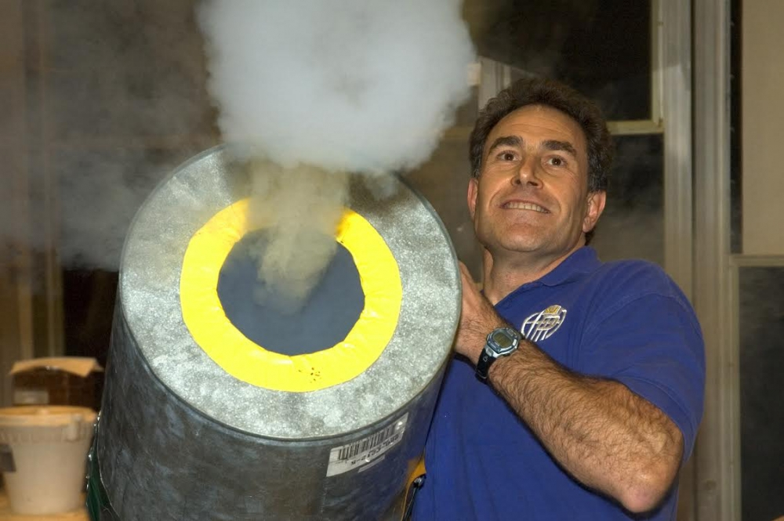

Physics has long been reputed for its complex formulas and its perplexing concepts, but two college professors are looking to simplify it by bridging science with theater.
David Maiullo, a physics support specialist at Rutgers, and Eric Krebs, a producer and professor at Baruch College, have put together an off-Broadway physics demonstration show called “That Physics Show.” The play consists of various experiments that demonstrate the basic laws and equations of physics.
“We actually show how these physics principles, these equations that we test people about all the time, are really just very simple things to see in actions,” Maiullo said. “This gives people a much more immediate feel for the physics that they have to do in an equation”
The show takes concepts that are normally presented as mathematical constructs and makes them easily digestible in the form of a demonstration, he said.
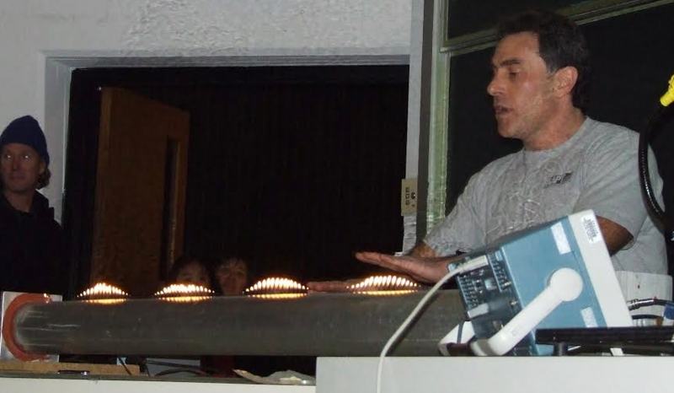
Photo by unknown |
30051902A Science Christian Hansen for the New York TimesThe Secret Science Club meets once a month in the basement of a Park Slope bar called Union Hall. The club is more of a loose assortment of twenty-somethings (as well as some older folks) who come to see free science lectures presented by real scientists. The people who come are not scientists, but really love science. The last time the Secret Science Club got together, Wednesday Nov. 7, there were two hour long presentations. The first to present was David Maiullo, of the Rutgers University Physics Dept. He used a cannon that shot out smoke rings to demonstrate fluid mechanics. The cannon was made out of an old metal garbage can.
He begins by breaking down the equation into its parts and demonstrating how manipulating a single part of the equation creates an effect. An example of this is pulling a tablecloth from underneath a pile of dishes in order to show what inertia is, he said.
Other demonstrations include using a fire extinguisher to propel a cart across the floor to demonstrate one of the laws of motion, exploding hydrogen balloons to discuss density and crushing a 55-gallon drum by removing the internal pressure to demonstrate how heavy the atmosphere is.
“We not only do the experiment and show something kind of fantastic, but we make sure that they understand the physics behind it too,” Maiullo said. “We don’t want to be magicians. We don’t want to show them things and be like ‘Hey I understand this and you don’t.’”
The idea to turn the show into a play came after Maiullo did his demonstrations in a theater appreciation class taught by Krebs, he said.
Krebs, a Rutgers alumnus and founder of the George Street Playhouse, strives to make theater more accessible to people who are not familiar with it, he said. He has been involved with the business for nearly 50 years.
Krebs saw Maiullo doing a demonstration and thought to present it to his theater appreciation class as a theatrical piece instead of a science demonstration. Maiullo did his demonstrations for multiple semesters, and the two have been thinking about making it an off-Broadway show for years, Krebs said.
“I hope (people) are entertained and amazed,” Krebs said. “I hope, especially younger people, take away a sense of ‘I want to know more about science.'”
Maiullo said his main inspiration for starting the demonstrations was seeing how much students did not enjoy coming to physics class. Using demonstrations helps bring physics to life, allowing students to appreciate the class.
Understanding the math behind physics before trying to learn physics is important, as learning the math and the concepts simultaneously is can be confusing, he said.
“I think one of the ways that trip people up in physics class is that they’re trying to do both at the same time. They don’t really understand the physics because they don’t really understand the math. That’s what hurt me a lot when I was in undergraduate,” Maiullo said.
Having a good understanding of the concept does not always equate to great test scores, but it does help maintain students’ interest in the class, Maiullo said. Engaging students and providing them with a different way to think about the concept is why the demonstrations are done.
His initial interest in physics came at age 10 while looking at Saturn through a telescope. With this interest in space and physics, Maiullo began to read science fiction, which translated basic concepts into fantastic ones.
Following his passion for physics, Maiullo enrolled at Rutgers to become a physicist, but did not perform well.
“I found out that I didn’t really have the tenacity to band my head against the wall and become a professor or anything like that. But I still loved physics,” he said.
After working on a project to build a particle detector to be used in Japan, a job became available to design demonstrations. At this time, not many professors used demonstrations, and a group of people across the country hoped to change that, Maiullo said.
This group, called the Physics Instructional Resource Association (PIRA), does physics demonstrations and shows across the country for people of all ages, from classrooms to bars to senior citizen centers.
“A lot of people have heard about how I do these shows,” Maiullo said. “I’ve gotten on TV shows, The Weather Channel, Discovery Channel (and) National Geographic, doing a lot of physics and explaining a lot of the principles of some of the shows that they have on TV.”
The enjoyment students take from these shows is further exemplified by the fact that they often wind up on social media.
John-Baptist Kauzya, a School of Engineering junior, works with Maiullo to prepare the demonstrations before every show. Kauzya got involved after another worker saw him looking at the demonstration and suggested Kauzya work behind the scenes to get a better understanding.
“When it comes to the demo shows, (my favorite part) is definitely seeing the people’s expressions when they see some of the demos,” he said. “Just seeing the happiness in people’s faces when they see the demos we’re putting on.”
Maiullo does not have a general plan for the future. If the play is successful off Broadway, it could eventually translate to Broadway and traveling shows across the country.
“I don’t necessarily have a general goal, but my love of physics is such that I’d love to see other people enjoy it more. Maybe (we will) have more people interested in physics and do what I do, and succeed more in physics due to what we do,” he said.

